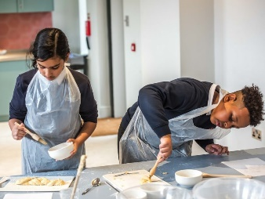
Manchester Jewish Museum School Visit Enquiry Form
Please fill in the below form so we can best support your school group visit to the Manchester Jewish Museum. Please note that this is just an enquiry form, not a confirmation of booking. You will receive confirmation once your enquiry has been processed by a member of our Programming Team. By completing this form you are giving permission for Manchester Jewish Museum to contact you about future schools opportunities. For further information on how we might use your data, please view our Privacy Policy here.
If you require further assistance or want to send in a completed form, please email schools@manchesterjewishmuseum.com or ring 0161 834 9879. We look forward to welcoming your class soon!

Name of teacher/booker
Name of School
Telephone contact
Email contact
Postcode of school
Date/s you would like to book visit (please provide several dates so we can best cater for your class and check availability)
Number of students visiting
Number of teachers visiting (please note, we recommend 3 – 5 teachers for a class)
Which workshop would you like to book for? Synagogue and Sabbath or Festivals and Feasts? Please look at our website for details of what the workshops involve.
What time would you like to visit? (We offer a morning session from 10am – 12pm, or an afternoon from 12.30 – 2.30pm, you can do a full day with both workshops from 10am - 2.30pm)
Year group
Any accessibility requirements? Or dietary requirements for the baking workshop?

Is this the first time you’ve visited Manchester Jewish Museum?
Any other information you’d like to share?
